Resources on Ukraine and supporting displaced Ukrainian scholars, writers, artists, students… (as well as dissident Russian and Belorusian couterparts at risk) from my scholarly networks:

Live events and ongoing discussions on Ukraine and Russia with scholars, writers, translators, curators, and others within the literary, arts, and scholarly communities:

- ASEEES Ukraine Events Calendar (https://www.aseees.org/resources/ukraine-events-calendar) continually updated calendar with links to upcoming panels, webinars, discussions, readings, etc., on Ukraine, from a broad interdisciplinary scholarly community affiliated with the Association for Slavic, East European, and Eurasian Studies

- Slavic Review Discussion: War Against Ukraine (http://www.slavicreview.illinois.edu/discussion/) ongoing moderated discussions from the Slavic Review – Interdisciplinary Quarterly of Russian Eurasian, and East European Studies

- HURI: Harvard University Ukrainian Research Institute Resources on Russia’s War on Ukraine (https://huri.harvard.edu/russia-ukraine-war) including historical contexts, current voices from Ukraine, commentary and documentary videos, news roundup (with curated links to general analysis, military analysis, diplomatic negotiations, statements from Ukrainian authorities, Russian news and strategy, US and European response, cyber and hybrid warfare, Belarus, refugees, profiles of “everyday Ukrainians” in wartime, etc.), and another Ukraine events calendar

- Words Together Worlds Apart: Voices for Ukraine, poets & translators from Ukraine and the US, Tuesday, March 1, 2022, 12:30-2:30 p.m. New York, 7:30-9:30 p.m. Kyiv (recording https://www.youtube.com/watch?app=desktop&v=XTnDRmOhKos)

- PEN America: Voices of Ukraine: Readings in Support of Ukraine, Friday, March 4, 2022, 2:00-3:30 pm ET (recording: https://www.youtube.com/watch?v=s_9YI6ihFQQ)

- Open letter from PEN International, signed by more than 1000 writers: https://pen-international.org/news/nobel-laureates-writers-and-artists-worldwide-condemn-russias-invasion-of-ukraine

Links to recent poems on war and displacement by Ukrainian poets (since the Russian invasion of 2014):
- https://lithub.com/february-get-the-ink-and-weep-contemporary-poetry-from-ukraine/?fbclid=IwAR3NP-PbdYqBMHLX1L5iftoZqX06uHVU0WGj98VR8uB7HmTvc-3H-Wt-GDI

- https://www.wordswithoutborders.org/article/april-2016-women-write-war-the-whole-soldier-lyudmyla-khersonska-katherine

- https://www.tupeloquarterly.com/tag/Lyudmyla-Khersonska/

- https://www.asymptotejournal.com/poetry/iya-kiva-a-little-further-from-heaven/

- https://www.wordswithoutborders.org/dispatches/article/women-writing-war-redux-ukraines-iya-kiva-katherine-e-young

- https://lareviewofbooks.org/short-takes/ukrainian-poems-of-war-khersonsky-kiva-makhno/

- https://www.poetryinternationalonline.com/ukraine-feature-words-for-war/?fbclid=IwAR3502c4CNfUulorlCBu-mdCWrVU_-AHGUSVKXqHJYVFCxLzcSrKC_ymRsA

- http://l.academicstudiespress.com/borderlines/poem/decomposition_ukr/?fbclid=IwAR1KNw4V2mTwAOiiTVRsSoHf3U5aATQUCUD7czYZBxMd-9p56-WS19HsFxw

- http://l.academicstudiespress.com/borderlines/poem/Darkness_Invisible_ukr/?fbclid=IwAR1mkYKl_cghiOU2T6cNqAKkE7tIF8qRkHukkHm7SAmL0bJVJnEmFLhdT8k

Organizations that offer humanitarian support:

- Unicef (https://www.unicef.org/emergencies/conflict-ukraine-pose-immediate-threat-children)

- Nova Ukraine (https://novaukraine.org)

- Ukrainian Institute of Modern Art links to organizations supporting humanitarian aid (including humanitarian aid organizations specifically for marginalized groups, for children, for refugees, for animals), as well as military and medical efforts in Ukraine (https://uima-chicago.org/ways-to-support-)

US Resources for Ukrainian scholars and artists in need of assistance:

- Association for Slavic, East European, and Eurasian Studies (ASEEES) list of resources (https://www.aseees.org/resources/help-displaced-scholars-ukraine) (including links to many of the websites listed below & other resources) in collaboration with the International Taskforce for Displaced Scholars

- #Science for Ukraine (https://scienceforukraine.eu/) coordinated hub of resources for scholars

- New University in Exile Consortium (https://newuniversityinexileconsortium.org/), The New School (contact aparetskaya@newschool.edu)

- IIE Scholar emergency funding and support (https://www.scholarrescuefund.org/)

- Artists at Risk (https://artistsatrisk.org/2022/02/26/ukraine-emergency-resources-for-artists-and-cultural-workers/?lang=en) with lists of residencies and other resources for artists and cultural workers from Ukraine, dissident Belarusian and Russian artists and cultural workers at risk, as well as hosting organizations

US Resources for Ukrainian students:
- SSR Special Student Relief (https://studyinthestates.dhs.gov/students/special-student-relief) (suspension of certain regulatory requirements by the secretary of the U.S. Department of Homeland Security (DHS) for an F-1 student from parts of the world that are experiencing emergent circumstances) The US Department of Homeland Security has designated Ukraine for Temporary Protected Status for the next 18 months. Cf. University Alliance for Refugee & At-Risk Migrants (UARRM) Guide for Universities & Guide for Student Advocates
- https://www.iie.org/en/Programs/Emergency-Student-Fund/Current-Funding-Efforts Emergency funding for Ukrainian students nominated by member institutions

*Extensive resources from European institutions (Germany, Poland, Sweden, Switzerland, UK, etc.) for displaced students and scholars are linked within the ASEEES list of resources

Resources from the Ukrainian Community in Rochester:

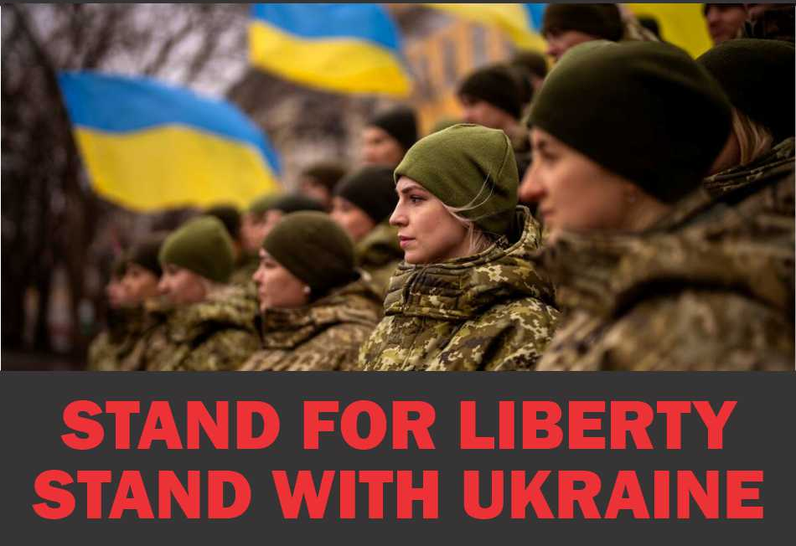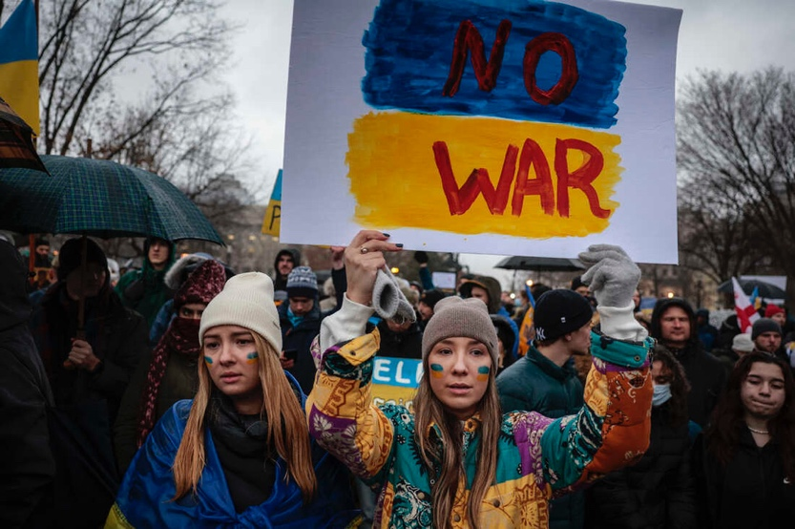

- Ukrainian Cultural Center of Rochester (https://www.uccofrochester.org)

- RocMaidan (https://www.rocmaidan.org) (Humanitarian aid subsidiairy of the Ukrainian Cultural Center of Rochester established in 2014 to support democratic movements in Kyiv

Resources for further reading:

- “Voices from Ukraine: A Reading List” from Words without Borders
https://www.wordswithoutborders.org/article/voices-from-ukraine

- Ukraine Research Guide from New York University
https://guides.nyu.edu/Ukraine/about?preview=f720d668ccbaebca276d0380e39a17a4

- “6 Books to Read for Context on Ukraine” from The New York Times https://www.nytimes.com/interactive/2022/02/25/books/ukraine-books.html

(You can read the The New York Times, the London Sunday Times, and many other news & scholarly journals online for free online through Drake Library. This includes East/West: Journal of Ukrainian Studies, SEEJ: the Slavic and East European Journal, and Slavic Review.)

Ukrainian Artists:

Pavlo Makov
https://www.france24.com/en/tv-shows/encore/20220301-it-s-morally-impossible-to-leave-my-home-artist-pavlo-makov-stands-firm-in-kharkiv

https://thenakedroom.com/en/pavlo-makov

